2016 Getting Started With “13Documents.com”
7-22-16
Why? Why do you need to submit documents via the “13 Document Portal”?
These documents will be transferred to the Trustee securely; thereby protecting the Debtor(s) privacy.
This is a portal for attorneys to submit (PDF) documents.
Debtors are not allowed to submit documents via this portal.
You need to redact PII from documents prior to submission.
(PII = Personally Identifiable Information)
Please note the following:
Documents must be in a PDF format.
Document file size must be smaller than 10 Mb per document.
ALWAYS upload multiple documents of the same type SEPERATELY and use the “Document Description” box to indicate more information about the document.
Upload TAX RETURNS for each year separately and enter the tax year in the document description. IE DO NOT put multiple years of tax returns in the same PDF…do not mix personal tax returns and business tax returns in the same PDF. One PDF for each spouse if filing separately.
When submitting BANK STATEMENTS one PDF for each account.
When submitting PROFT\LOSS statements submit for each business separately.
When submitting APRRAISALS\VALUATIONS submit them separately for each item.
When submitting PAY ADVICES one PDF for each individual but separate PDF’s for different employers.
Note: Not following the above instructions will result in your having to resubmit your documents.
STEP 1: REGISTRATION & ACTIVATION
- Go to https://www.13documents.com and click on the “REGISTER” link at the top right hand corner of the page.

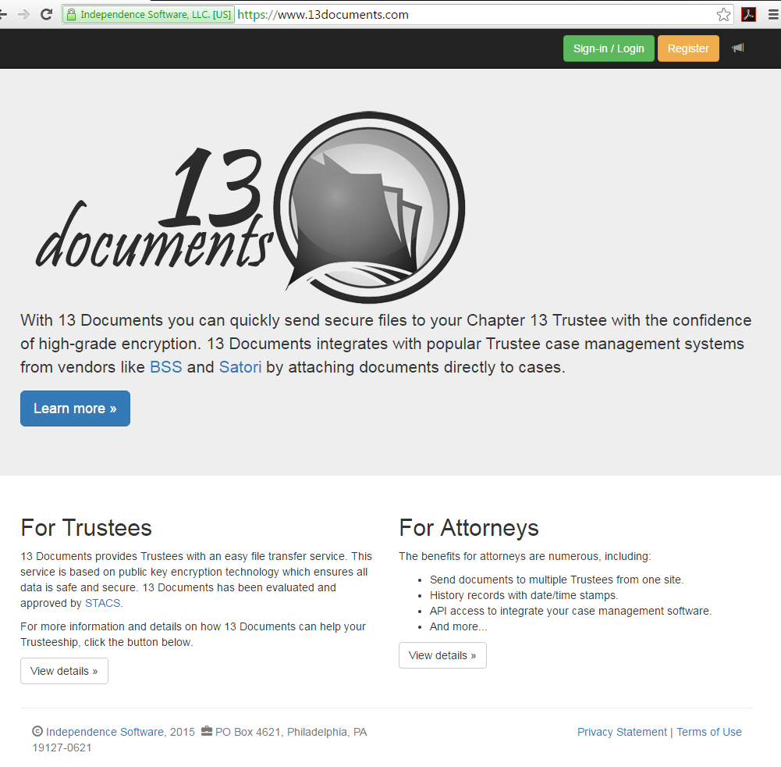

Enter you email address in the “E-Mail Box”

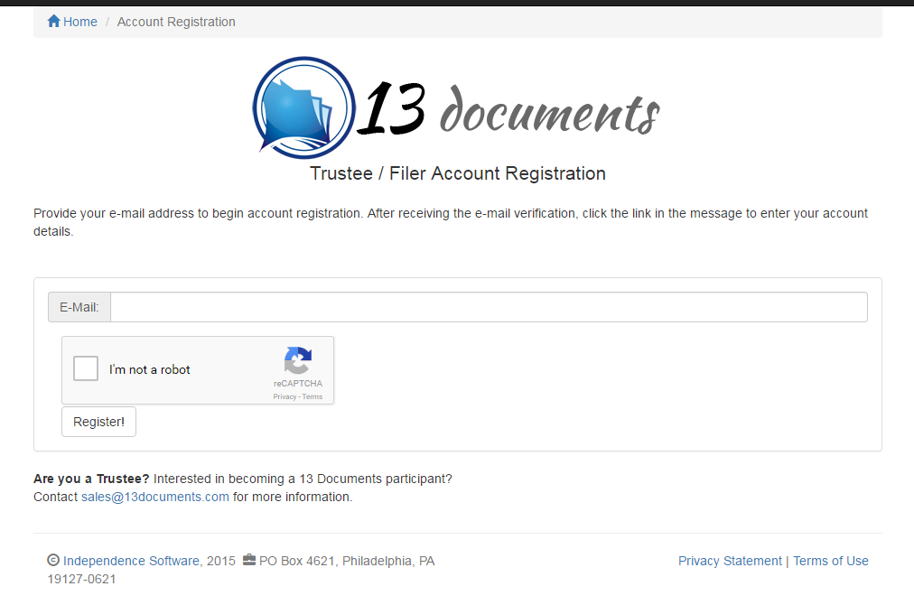
Check the box “I’m not a robot.”

Once you check the box “I’m not a robot” another dialog box will open with pictures where you will have to make selections to prove that you are not a robot. These pictures vary and will not necessarily be the same as the ones displayed below. Once you have selected the pictures single click on “Verify”.

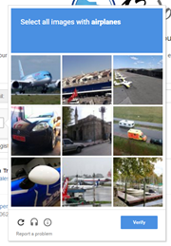

When you are done selecting the picture please click “Register.”

You will need to check your email for a “13 Documents” registration email.

Once you have selected “Register” this screen will appear.
Single click on “Activate Now”.

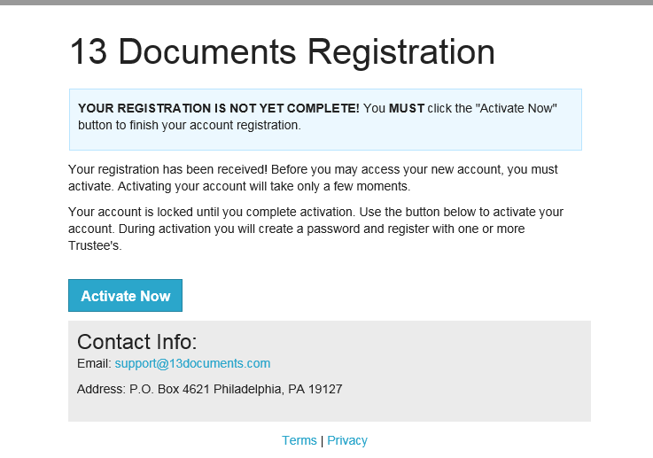

You will need to fill in ALL the fields to complete your registration.
When you check the box “I’m not a robot” you will have to select all the objects that match and then select “Verify”. Then you need to select “Update”.

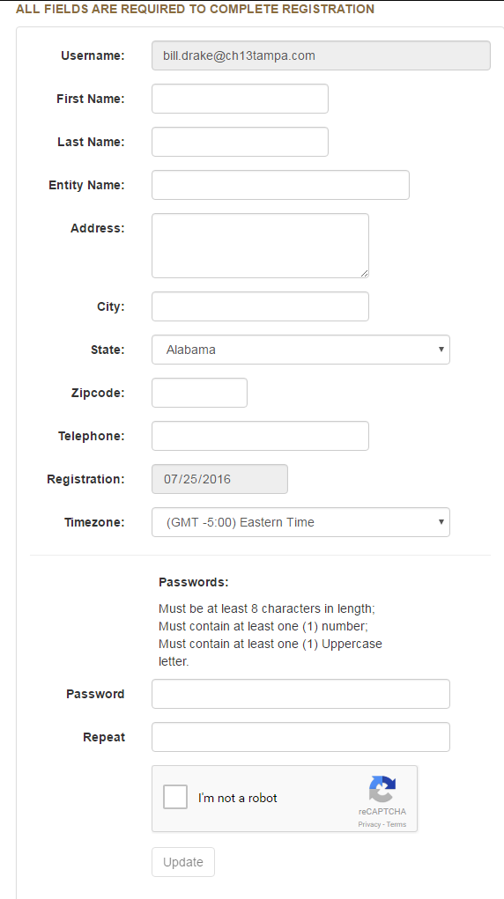

Note: You will be required to change your password every ninety days.
This is the next box that appears. Select “Request Trustee Acess”
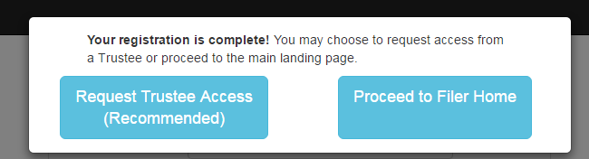

You next need to selct “Kelly Remick” as your Trustee by clicking on the “Request” button. Make sure you pick your Trustee.
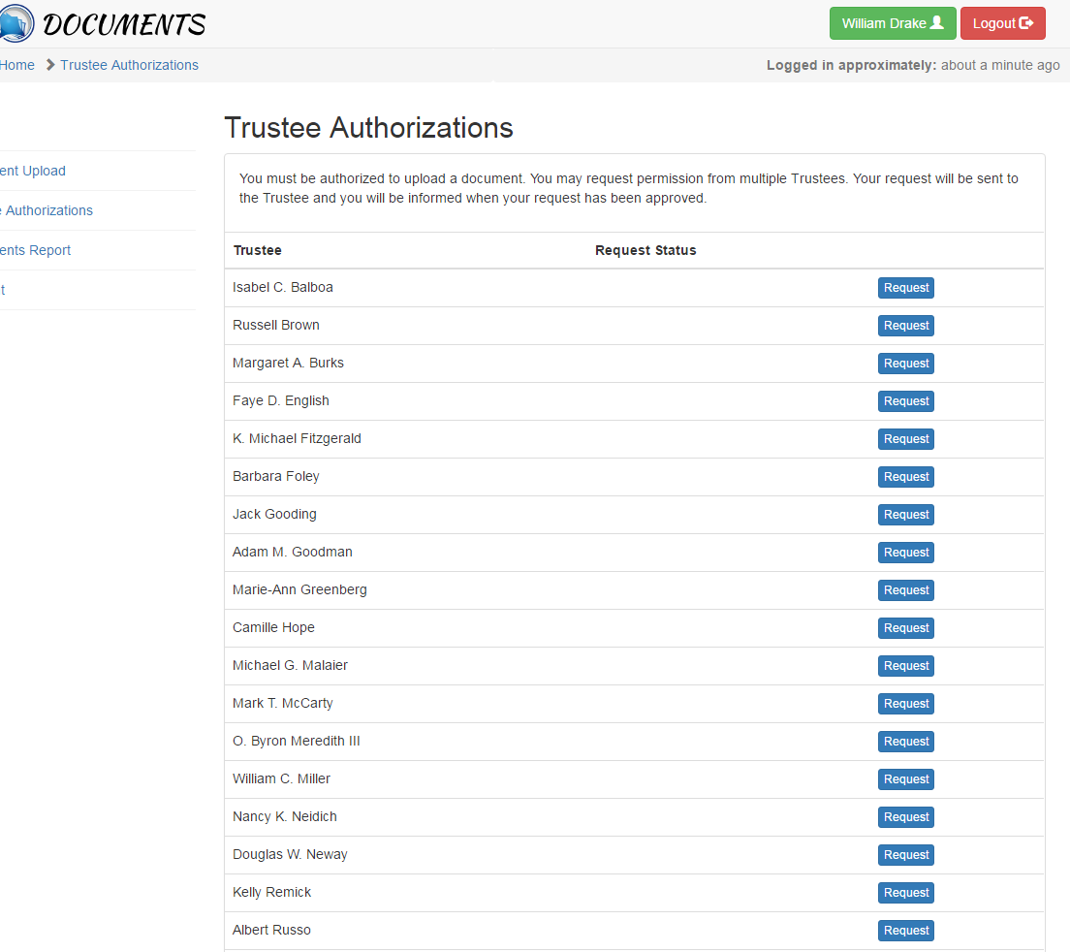

After you have selected “Kelly Remick” you will see the request is “Pending”.


You will next receive an email and text will look like what is displayed below.
The next step is to “Activate Now” to complete your registration for your account.

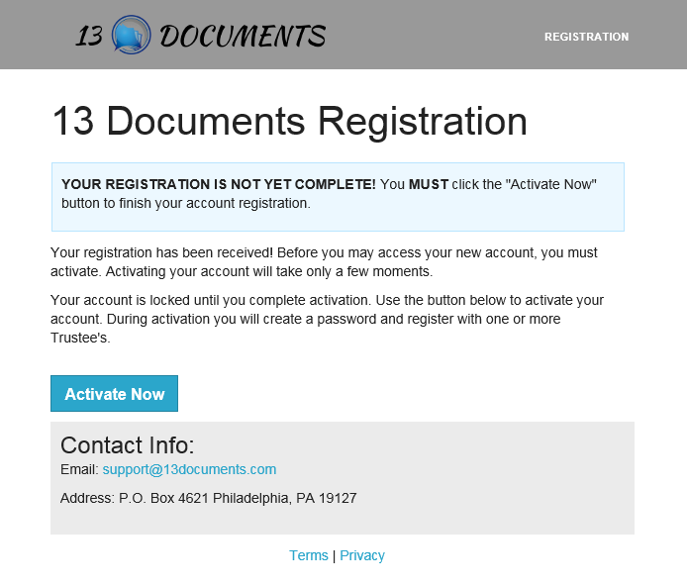

Your Trustee office will receive an email and they must approve your application before your registration can progress and you can begin uploading documents.

If you do not receive an email that your application has been approved in thirty six hours please contact William Drake at 813-658-1165 at extension 120.

STEP 2: UPLOAD DOCUMENTS
Note*: It is recommended to wait three (3) days after a case is filed before attempting to upload a document. Otherwise you may receive an error indicating an invalid case number.

Go to https://www.13documents.com and select “Sign-in/Login”.

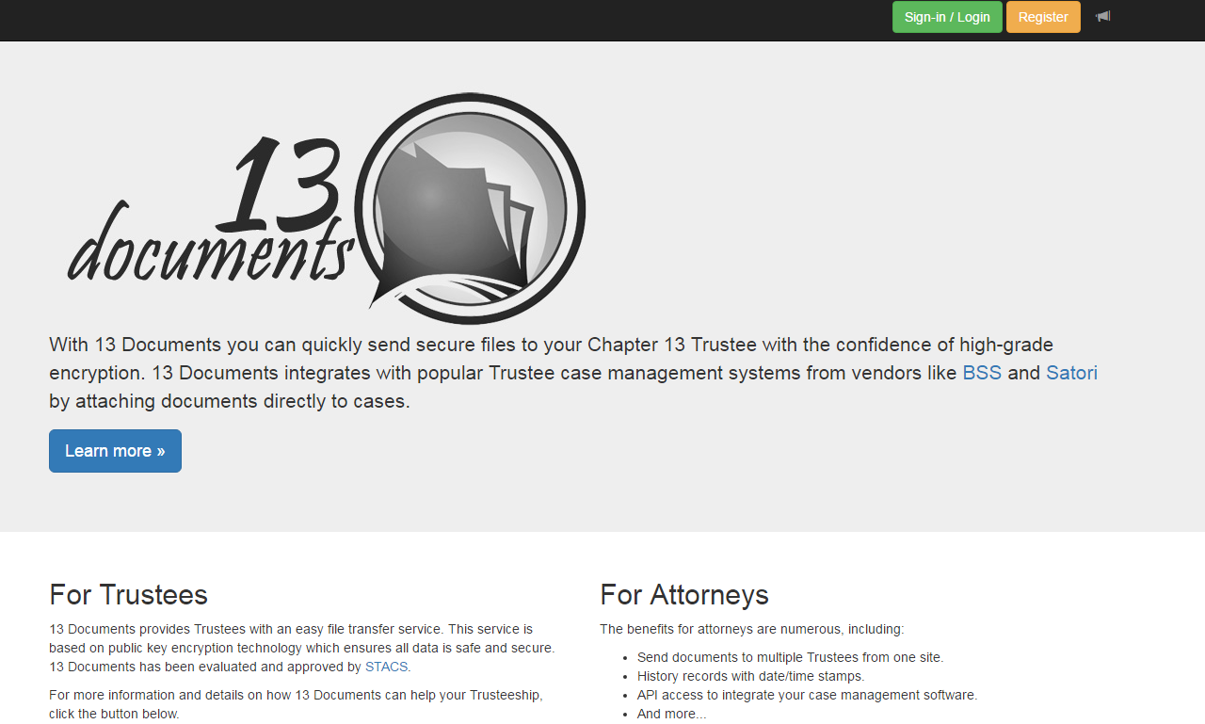

Enter your “Email” address and “Password” and “Sign in”.

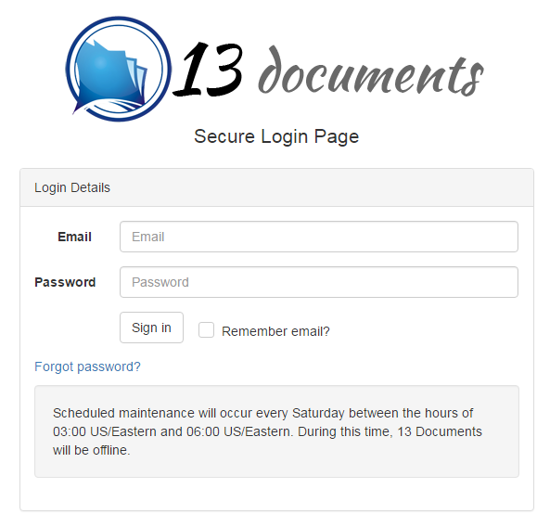

Select “Document Upload”

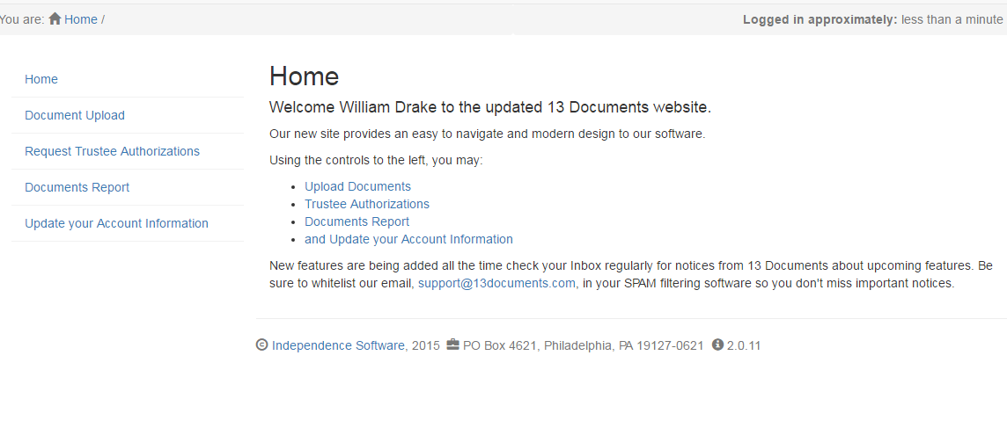

Under “Select Your Trustee” highlight “Kelly Remick”
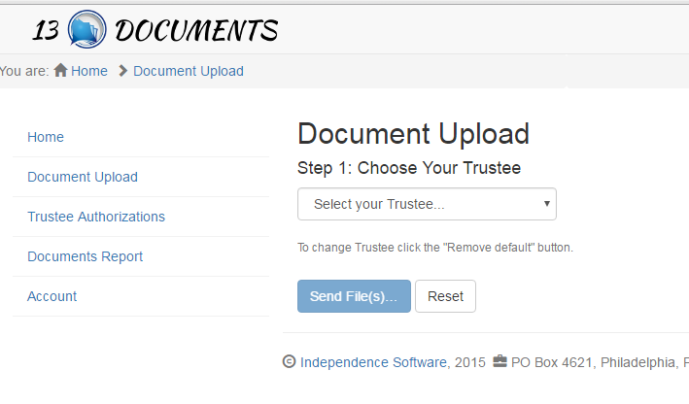

The next screen that will appear will be as follows….click on “Browse” to go to the location on your computer of the “PDF” that you want to send.
You can upload up to ten (10) documents at one time.
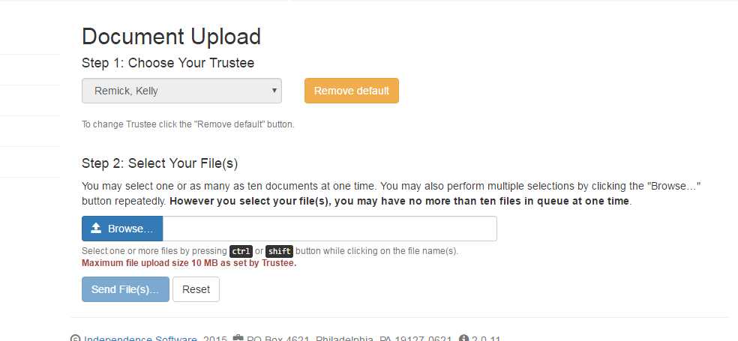

Select the document that you want to send which in this case is the “Tax Returns”.

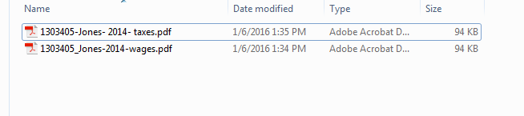

You must name your document so it is identifiable.
The case number must be entered without the dash, the debtors name, and the year and type of document. Do not send multiple year or mixed catergory documents in the same pdf.

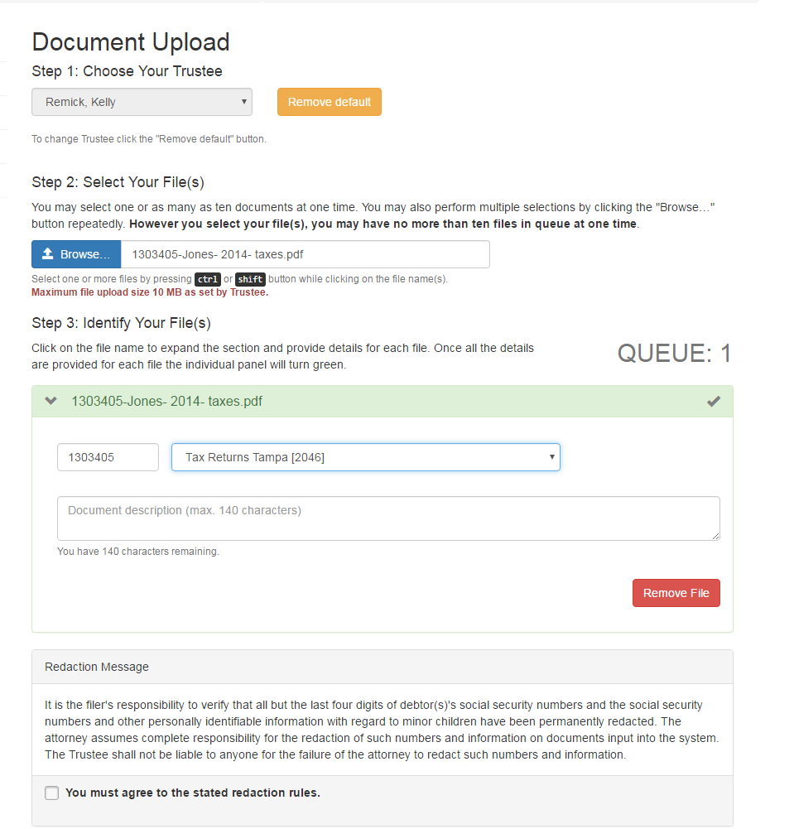
You will also need to chose the type of “document” from the pull down box.
You also need to enter the “document description” in this box.

These are the types of documents currently available in the system. (Chose one.)
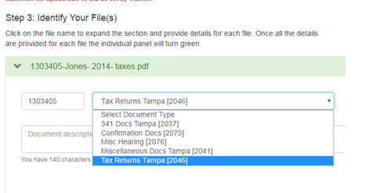

There is a notation about “Redaction” and you need to check the box and single click “Send File(s)”.
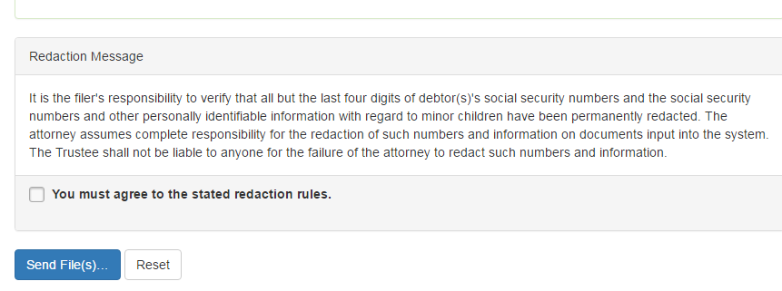

Once you have sent the files you will see this notation that the documents have been uploaded.
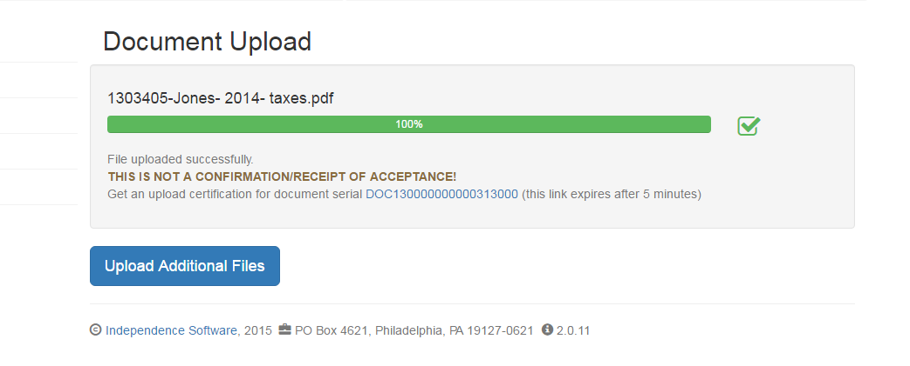

You will want to click on this link to get the “Certification of Document Receipt”.

This is the “Certification” of the documents you have sent.
You will want to make a copy of this.
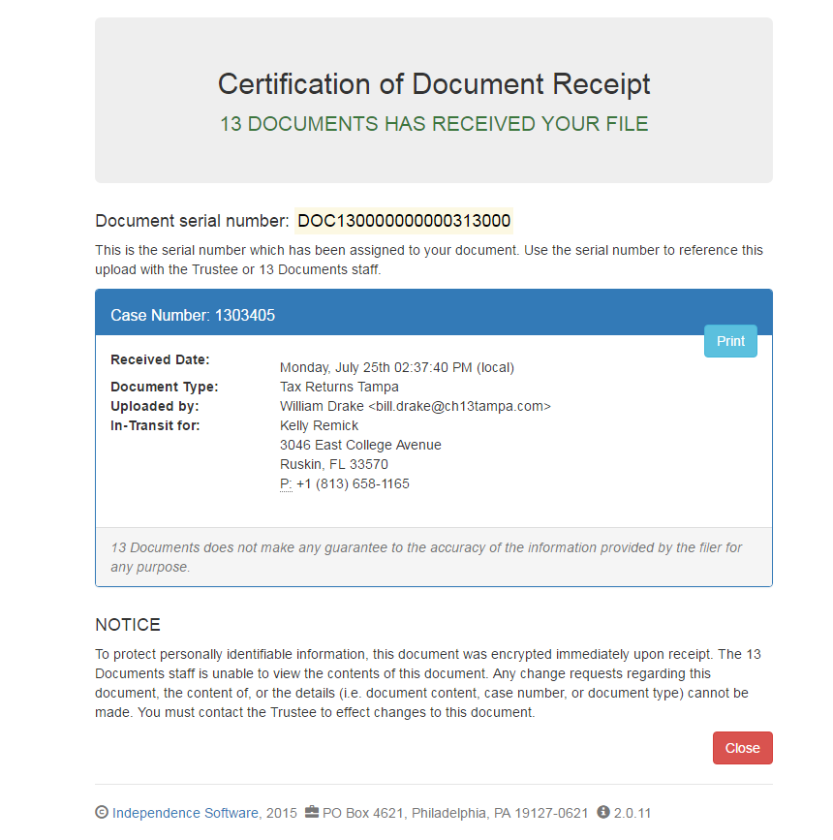

ADDITIONAL NOTES-
MULTIPLE DOCUMENTS
You may upload more than one document at a time – if you were to select two documents then the screen would appear as shown below. Remember the maximum size of any ONE document is less than 10 Mb.

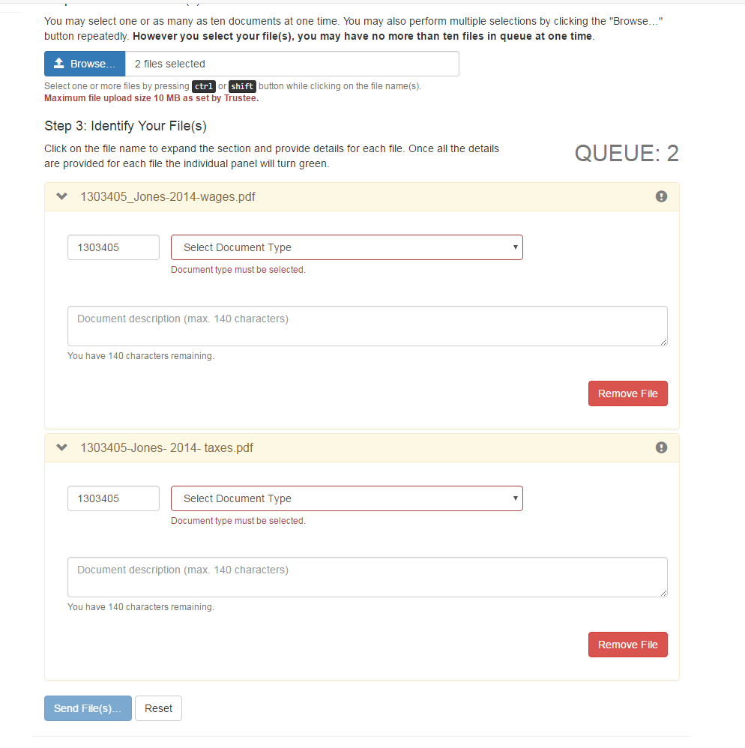

DOCUMENT REPORTS
If you select the “Document Report” from the left hand banner you can see what items you have uploaded. The number of items in the report is currently not restricted.

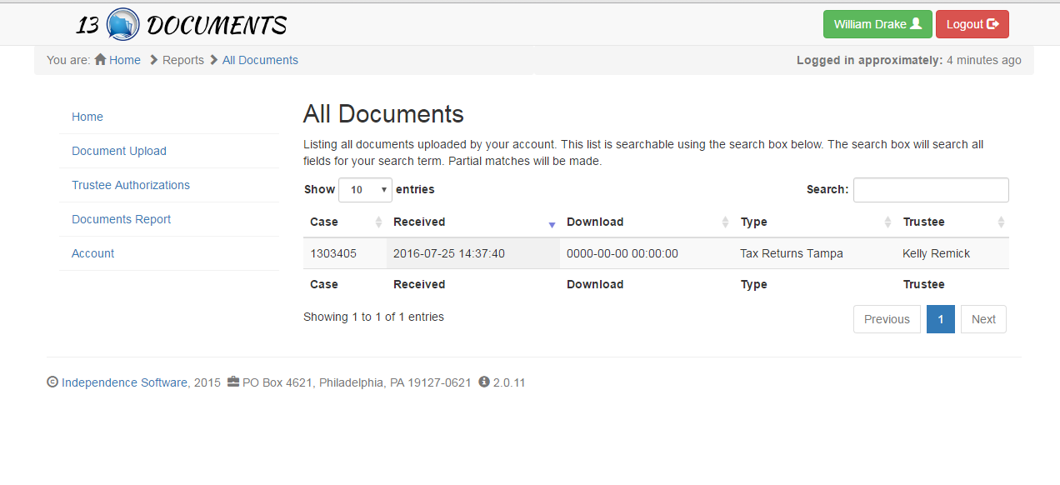
ACCOUNTS
If you select “Account” from the left hand side you can change the infomration in your account such as your address, email address, etc.

FORGOT YOUR PASSWORD ?
If you forgot your password you can go to the main login and single click on “Forgot password?”

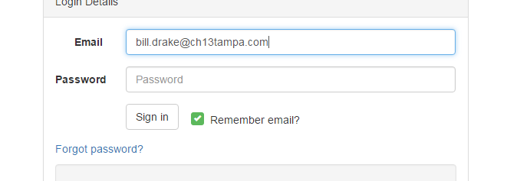

Enter your “Email” address, pass the “I’m not a robot” and “Send Reset”.

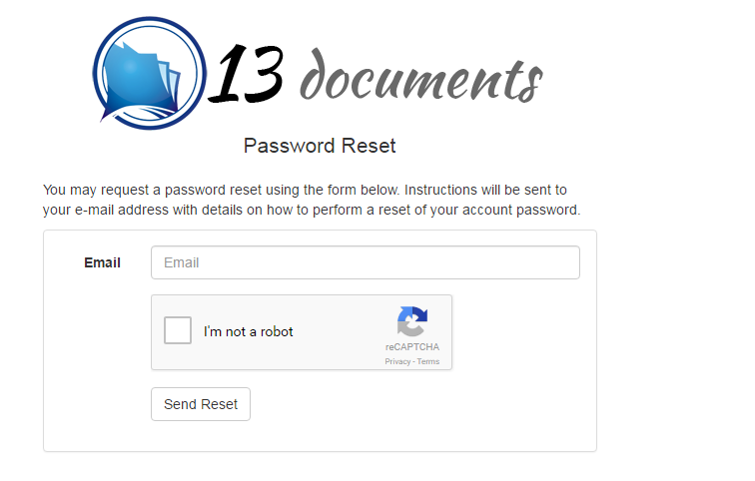

When done using the site please remember to “Logout”

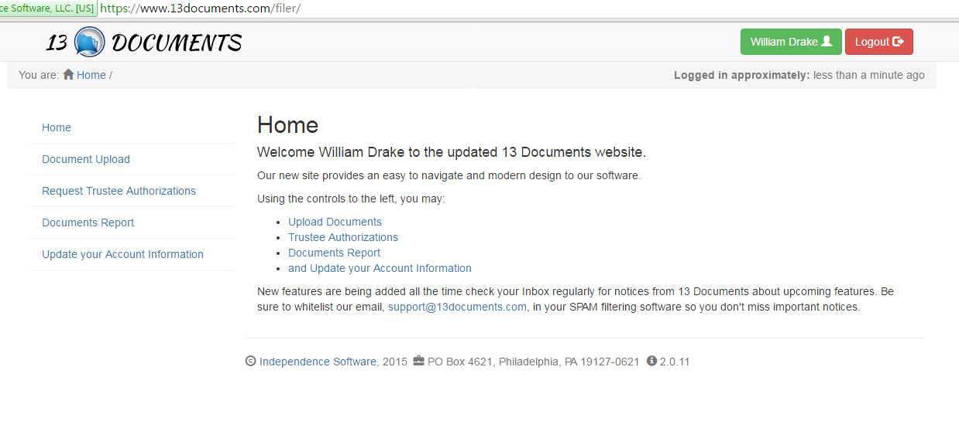

If you need assistance, please contact William Drake at the Trustee’s office.
(813-658-1165 x 120)
If you have any suggestions on how this guideline can be improved, please call William Drake at the above number.

END

